Email option
[Email address]

Letter option
[Date]
[Name of Local Member]

Dear [Name]

RE: Four the Future of Road Freight – 2022 QTA Federal Election Priorities

I am writing to highlight the release of the Queensland Trucking Association “Four the Future of Road Freight: Generation Defining Investment for the Road Freight Industry - Blueprint” and the priorities that are particularly relevant and important for my business. The QTA is the peak industry association representing road freight operators in Queensland from owner drivers through to major logistics companies. My business is a current financial member of the QTA.

It is time to make investments to increase the connectivity to export markets and ports and supply our communities in all weather. To achieve this, funding must be directed towards bridge infrastructure to strengthen the freight network.
It is essential that the party who forms the next Australian Government implement these Four Pillars of Generation defining investment for the road freight industry. These recommendations will propel the road freight industry towards a low carbon future that is efficient, productive, and commercially competitive. This is crucial to the prosperity and economic growth of both Queensland and Australia.
I urge you to support the following priorities:

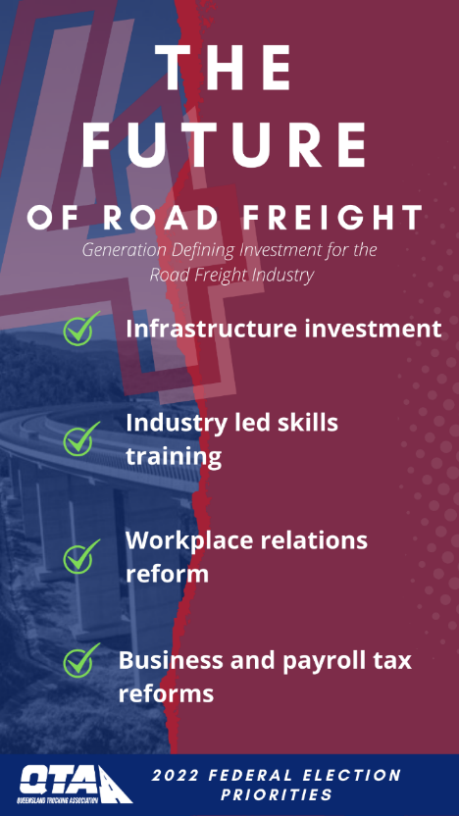

You can view the full Blueprint on the QTA Website.

I would welcome a discussion on these should time permit in your schedule.

Yours sincerely
[Name]
[Role]

